Economic Sentiment Dynamics and Forecasting:

An Applied Econometric Analysis

Linh Chi Tran

Table of content
- Introduction
- Data Description
- Methodology
- Results and Interpretation
- Limitation and Assumptions
- Conclusion

1. Introduction
This report presents an applied econometric analysis of economic sentiment indicators with the aim of understanding the dynamic behavior of the indicator KP and its relationship with KB and CP. The analysis focuses on model construction, validation, structural stability, nonlinear dynamics, and short-term forecasting.
The primary objectives of the study are:
- to estimate and validate regression-based models explaining KP,
- to assess model stability and structural changes over time,
- to explore nonlinear regime behavior using Markov-switching models,
- to generate short-term forecasts using a dynamic regression framework.
The analysis is conducted using R and emphasizes transparent modeling choices and interpretability.

2. Data Description
The dataset (Data_KON.xlsx) consists of time-series observations of economic sentiment indicators. The final version of the data includes the following variables:
- year – calendar year identifier
- KP – main economic sentiment indicator (dependent variable)
- KB – explanatory sentiment indicator
- CP – explanatory sentiment indicator
The data were preprocessed by sorting observations chronologically and creating a one-period lag of KP for dynamic modeling purposes. No missing values were detected in the final dataset.

3. Methodology

3.1 Linear Regression and Diagnostics
The baseline model is estimated using Ordinary Least Squares (OLS):
KPt=α+β1KBt+β2CPt+εtKPt​=α+β1​KBt​+β2​CPt​+εt​
Model adequacy is evaluated using:
- residual plots,
- the RESET test for functional form misspecification,
- Breusch–Pagan test for heteroskedasticity,
- Breusch–Godfrey test for serial correlation,
- robust (HAC/Newey–West) standard errors.

3.2 Nonparametric Estimation
To relax linearity assumptions, a nonparametric kernel regression of KP on KB is estimated. This allows for inspection of potential nonlinear relationships without imposing a parametric structure.
Kernel density estimation is also used to examine the distributional properties of KP.

3.3 Dynamic Regression (ADL Model)
To capture persistence in KP, a dynamic regression model is estimated:
KPt=α+ϕKPt−1+β1KBt+β2CPt+εtKPt​=α+ϕKPt−1​+β1​KBt​+β2​CPt​+εt​
The presence of lagged KP introduces dynamic dependence. Long-run effects are computed using the standard long-run multiplier formula.
Because future values of KP are unknown, forecasts are generated using a recursive forecasting procedure, where each predicted value is used as the lag for the next period.

3.4 Structural Breaks and Outliers
Structural stability is assessed using:
- the Bai–Perron breakpoint test for unknown break dates,
- a Chow test at the midpoint of the sample as an illustrative stability check.
Outliers and influential observations are identified using Cook’s distance.

3.5 Markov-Switching Model
To account for potential regime-dependent dynamics, a two-regime Markov-switching regression model is estimated. This model allows coefficients and error variance to differ across regimes, capturing periods of distinct economic behavior.
Filtered regime probabilities are analyzed to identify transitions between regimes.

3.6 Monte Carlo Simulation
A Monte Carlo experiment is conducted to compare the behavior of unit root tests under:
- a random walk process,
- a white noise process.
This illustrates differences in test power and reinforces interpretation of time-series properties.

4. Results and Interpretation

4.1 Linear and Nonparametric Results
The OLS estimates suggest that KB and CP are statistically relevant predictors of KP. Diagnostic tests indicate the presence of serial correlation, motivating the use of dynamic and robust modeling approaches.
The nonparametric regression reveals mild nonlinearities in the KP–KB relationship, although the general direction of the effect remains consistent with the linear model.

4.2 Dynamic Behavior and Forecasting
The ADL model confirms strong persistence in KP, as indicated by the statistically significant lag coefficient. Long-run multiplier estimates suggest that changes in KB have a lasting impact on KP.
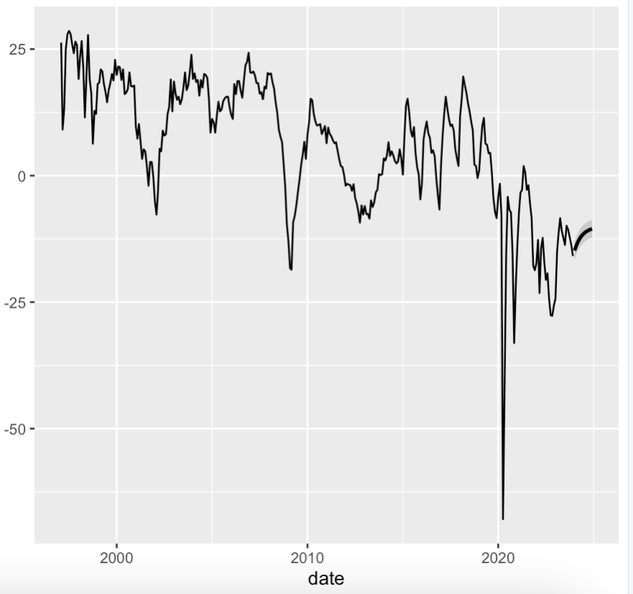
Figure 1 presents the recursive ADL forecast of KP for the next periods. Forecast intervals widen over the horizon, reflecting increasing uncertainty.

4.3 Structural Stability
Breakpoint analysis indicates potential structural changes in the relationship between KP, KB, and CP. These changes may correspond to different macroeconomic environments or sentiment regimes.
Cook’s distance highlights a small number of influential observations, though no single observation dominates the results.

4.4 Regime Switching
The Markov-switching model identifies two distinct regimes characterized by differing coefficient magnitudes and volatility levels.
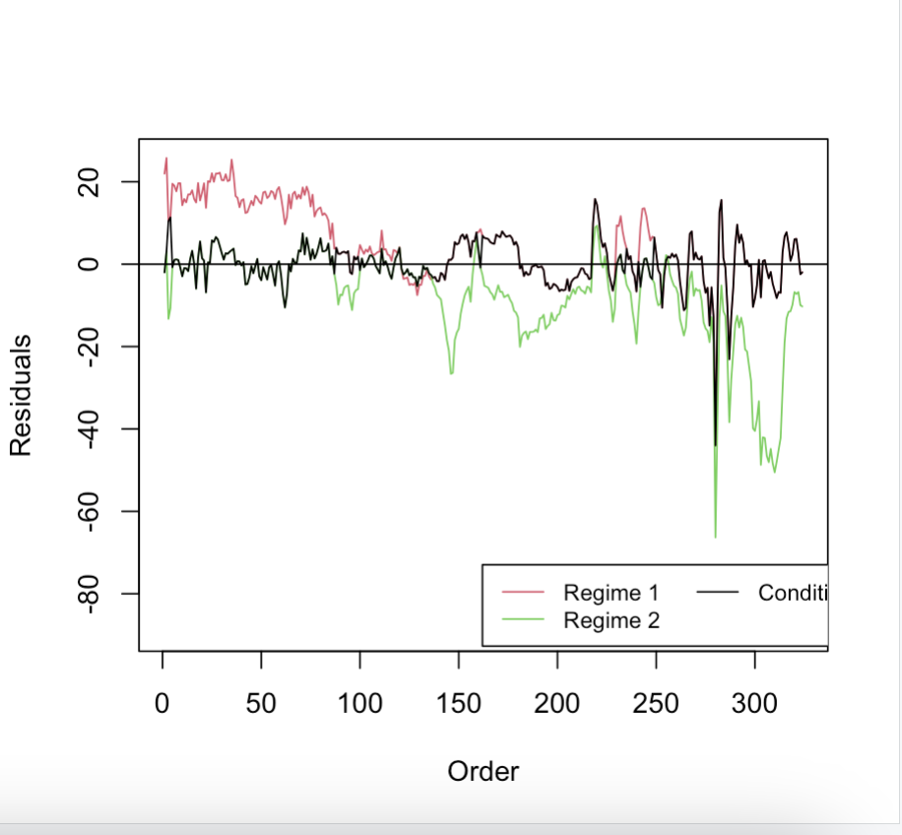
Figure 2 shows regime probabilities over time, suggesting persistent periods of high and low sentiment dynamics rather than frequent switching.

4.5 Monte Carlo Evidence
Simulation results demonstrate that unit root tests have low rejection rates under random walk processes and substantially higher rejection rates under white noise, reinforcing the importance of correct time-series assumptions.

5. Limitations and Assumptions
Several simplifying assumptions are made:
- KB and CP are held constant at their last observed values during forecasting,
- the dynamic structure is linear within regimes,
- sample size limits precision in regime classification.
These assumptions are standard in applied econometric analysis but should be reconsidered with richer data.

6. Conclusion
This study provides a comprehensive applied analysis of economic sentiment indicators using linear, dynamic, and nonlinear econometric methods. The results highlight the importance of persistence, structural stability, and regime-dependent behavior in modeling KP.
Future work could extend the analysis by incorporating additional predictors, forecasting explanatory variables explicitly, or using higher-frequency data.

